ABSTRACT

Power electronic circuits (PECs) are the replacement of carburetor, spark plug etc. of a combustion engine that bring pace in the achievement of green energy revolution. Electric vehicles (EVs) have become an icon of choice in automotive industry. An integral part of any modern-day EV is PECs comprising of DC-AC inverters and DC-DC converters. A DC-AC inverter supplies the high-power electric motor and utility loads such as air-conditioning system, whereas a DC-DC converter supplies conventional low-power, low-voltage loads. However, the need for high power bidirectional DC- DC converters in future electric vehicles has led to the development of many new topologies of DC-DC converters. The H-bridge converter can be used as a DC-DC converter. In this study, a model of H-bridge PEC is devised that can operate a motor in both open loop and feedback methods with a view to regulating speed and torque. It comprises of a non-conventional freewheeling diode placement that ensures the continuity of current through motor when it is cut off from the supply. This topology comes into play when the main supply is unwilling to accept current and hence an auxiliary low voltage source can be charged up instead. Also a graphical user interface (GUI) application is prepared using MATLAB® that forms the foundation of remote control.

Keywords: H-bridge converter drive, Pulse width modulation (PWM), freewheeling diode, Proportional-Integral-Derivative (PID) controller.

CONTENTS
List of Tables and Figures …………………………………………………………..
Acknowledgements ……………………………………………………………………
1. Introduction ………………………………………………………………………..
1.1. Motor speed and torque control……………………………………………
1.2. PID controller in closed loop operation …………………………………..
2. Methodology ……………………………………………………………………….
2.1. Pretesting apparatus ………………………………………………………
2.2. GUI development …..…………………………………………………….
2.3. PWM signal generation …………………………… ……………………
2.4. PID parameter tuning ……………………………………………………
3. Model Description ………………………………..……………………………….
3.1. Model construction ……………………………………………………….
3.2. Model operation ………………………………………………………….
4. Results ……………………………………………………………………………..
4.1. Open loop control outcomes ……………………………………………..
4.2. Closed loop control outcomes ……………………………………………
4.3. Calibration figures in a nutshell …………………………………………..
5. Conclusions …………………………………………………………………………
6. References …………………………………………………………………………..
Appendix ……………………………………………………………………………
List of Tables and Figures

Table 1
Table 2
Table 3
Figure 1
Figure 2
Figure 3
Figure 4
Figure 5

Acknowledgements

The completion of this project would not have been possible without the support and supervision of our professor Dr. Md. Habibullah and lecturer Md. Sajjad Hossain. We are highly indebted to them. Our thanks and appreciations also go to Monirul Islam of analog electronics laboratory for his assistance. Thanks to all other people who have willingly helped us out with their abilities.

1. INTRODUCTION

As the focus in vehicular technology shift toward replacing more and more mechanical, hydraulic, or pneumatic systems by electrical systems, power electronic circuits (PECs) have gained a lot of importance in the last decade [1]. Increasing vehicular loads such as utility, entertainment, luxury, and safety loads have increased the demand for efficient PECs. H-bridge DC-DC converter is a PEC that has the functionality of driving DC motors. This converter’s voltage gain can be controlled by means of PWM signal. Also, motor can be run in both directions. Four quadrant operation is possible using this converter. However, regenerative braking feature is not included in the project and so, first and third quadrant operation is made.
H-bridge converter motor drive has the configuration resembling the letter “H,” with the motor located in the center and four switches (transistors or MOSFETs) arranged around it [2]. By controlling these switches, the H-bridge can effectively reverse the direction of the motor and adjust its speed and torque output [2]. In an electric vehicle (EV), for acceleration speed of motor is to be increased and vice versa while braking. Moreover, a vehicle’s load can be increased or decreased. Torque output of motor is thus required to be handled.
In this project a microcontroller-controlled H-bridge driver is modelled with MOSFETs as switches.
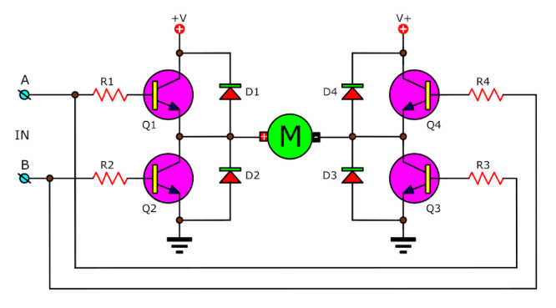
Figure 1: H-bridge DC motor drive [3]
Freewheeling or flyback diodes D1, D2, D3, D4 (Figure 1) are used in motor drive that prevent the high voltage over the switch across the inductive load terminals. This diode is used to protect the circuit from unusual damage due to the sudden decrease in the flow of current in the circuit . When all transistors Q1, Q2, Q3 and Q4 are off (Figure 1), the diodes fly back the energy stored in the inductor by a short circuit path in the main power supply [4]. If the main power is unable to receive the power, then the energy can be fed back to an alternative low power source. The project didn’t use the alternative source however due to unavailability, but a resistor was used for power dissipation which is although an inefficient approach, but handy for installing the alternative source with a separate DC-DC converter.
1.1. Motor Speed and Torque Control
Speed of a permanent magnet (PM) motor can be controlled by varying armature resistance. This is equivalent to controlling the supply voltage across motor terminals. If resistance is used, a portion of energy will be lost at the resistor. An alternative way is to put a variable DC source across motor terminals and can be materialized with a constant DC source and a DC-DC converter like H-bridge.
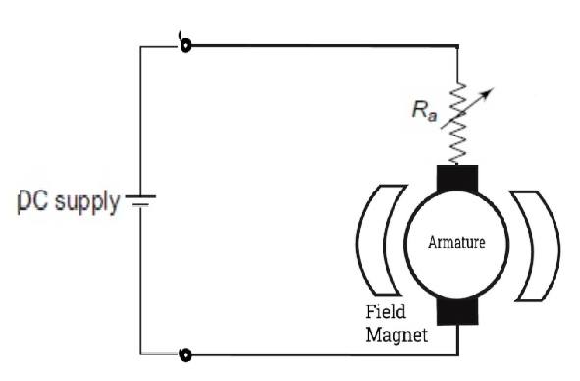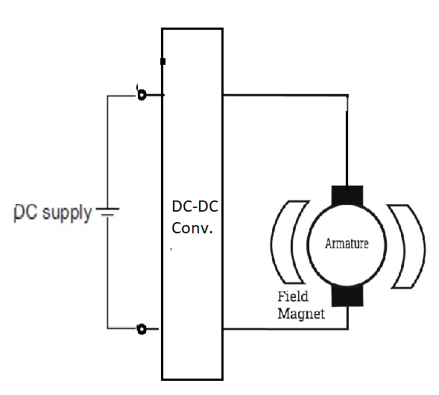
(a) (b)
Figure 2: (a) DC motor speed control by varying armature resististance and (b) by using a DC-DC converter

Speed of DC motor is regulated by the following equation:
$$Speeed=K_{s}×\frac{V- I_{a}R_{a}}{ϕ } (in rpm) (1)$$
Here, V = terminal voltage, I_{a} = armature current, R_{a} = armature resistance, $ϕ$ = field flux and K_{s} is speed constant that depends on motor design [5]. For a PM motor, $ϕ$ is constant and the numerator V - I_{a}R_{a} can be varied by either changing R_{a} or V. In case of H-bridge converter drive, V is varied by regulating pulse width modulated (PWM) signal supplied to the gate of MOSFETs.
Torque of a PM DC motor is,
$$T=\frac{60×E_{b}I_{a} }{2π×speed} (in Nm) (2)$$

Here, E_{b} = back emf and it depends on supplied voltage. For fixed speed rotation under variable torque, E_{b} is to be kept constant under variable armature current that is related proportionally to torque [4]. To keep E_{b} constant it is necessary to regulate supply voltage as per torque demand.
1.2. PID Controller in Closed Loop Operation:
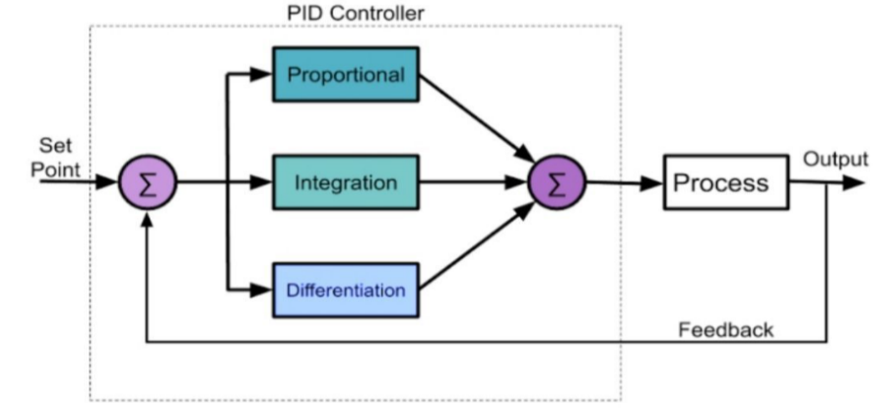
Figure 3: Block diagram of PID controller [6]
To control the speed of motor via feedback process a PID controller helps in many aspects. It monitors the speed (output variable as per Figure 3) of motor (the process according to Figure 3) and corrects any deviation from the set point speed via feedback.
2. METHODOLOGY
This project has travelled through many checkpoints. Checkpoints are summarized below in the flow chart:
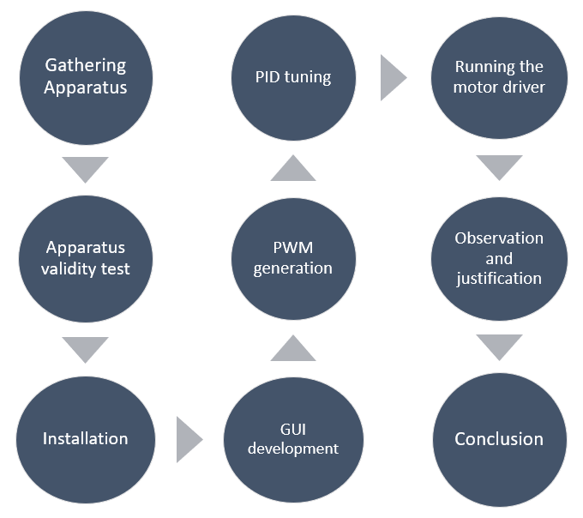
Figure 4: Project flow chart

H-bridge motor drive, designed in the project, is transistor controlled. Atmega microcontroller embedded on Arduino development board can generate PWM signal that triggers a MOSFET. The n-type MOSFET used in the model reaches saturation state with a gate-source voltage (V_{GS}) of 10 V. But Arduino system has the ability to supply 5 V maximum. So, Arduino is incapable to drive the H-bridge. More importantly, this attempt doesn’t isolate power electronic H-bridge circuit from microcontroller. Thus, if there was any fracture in H-bridge circuit, the microcontroller will be affected. Here comes the necessity of MOSFET driver. This driver does the job of isolation.
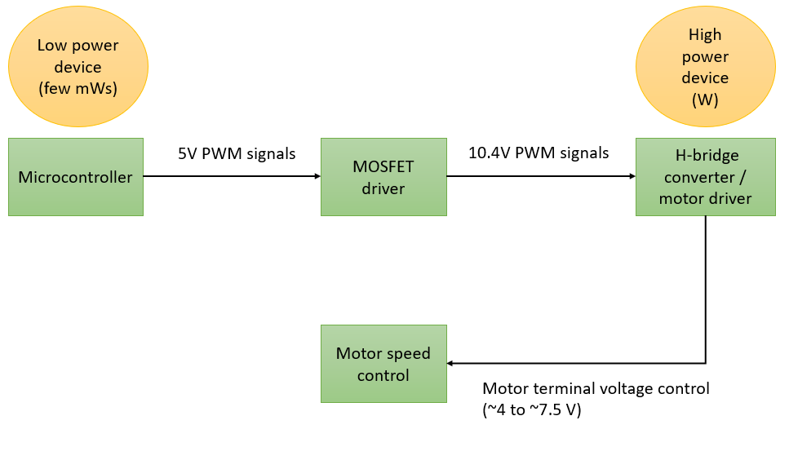
Figure 5: Execution steps to motor drive modelled for EV
2.1. Pretesting apparatus:
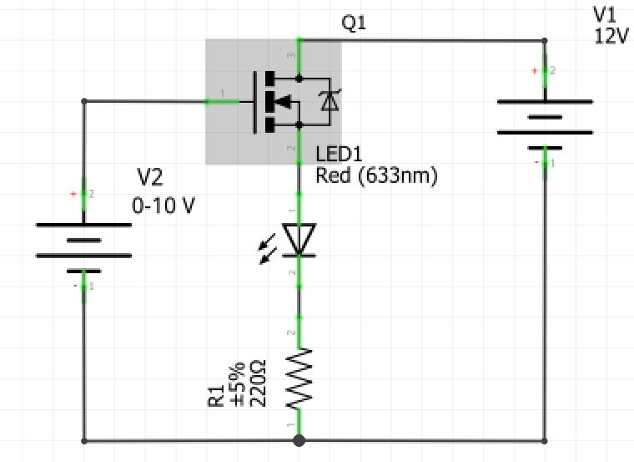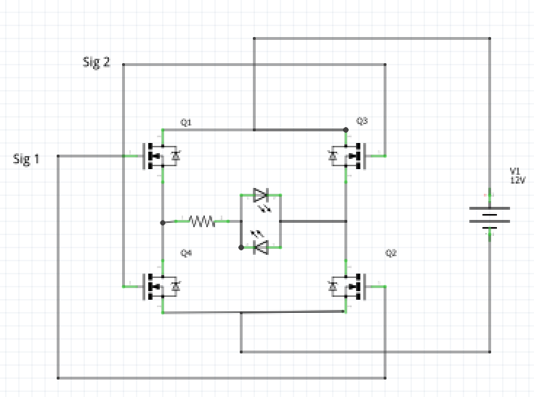
(a) (b)
Figure 6: (a) MOSFET operability check. A 10V V_{GS} input will turn on the LED if the MOSFET is operable. At a lower V_{GS}, the LED should be off. (b) Validity check of MOSFET driver and H-bridge converter. The signals 1 and 2 come from MOSFET driver. If the driver and converter is functioning correctly, the LED at top will turn on while the LED at bottom will be off if Sig 1 is high and Sig 2 is low. LED status will be inverted if Sig 1 and Sig 2 are inverted
In order to build up the whole prototype as shown in figure give, each component was tested beforehand. Without the functionality test of MOSFET and driver, it was not suitable to implement the prototype. Because, troubleshooting would be difficult. Pre-trials of apparatus are carried out as per Figure 7. After the trial, circuit connection was given which marked the end of installation process.
2.2. GUI development:
MATLAB® software was used to make an interactive environment for user to operate the H-bridge motor drive beside manual method.
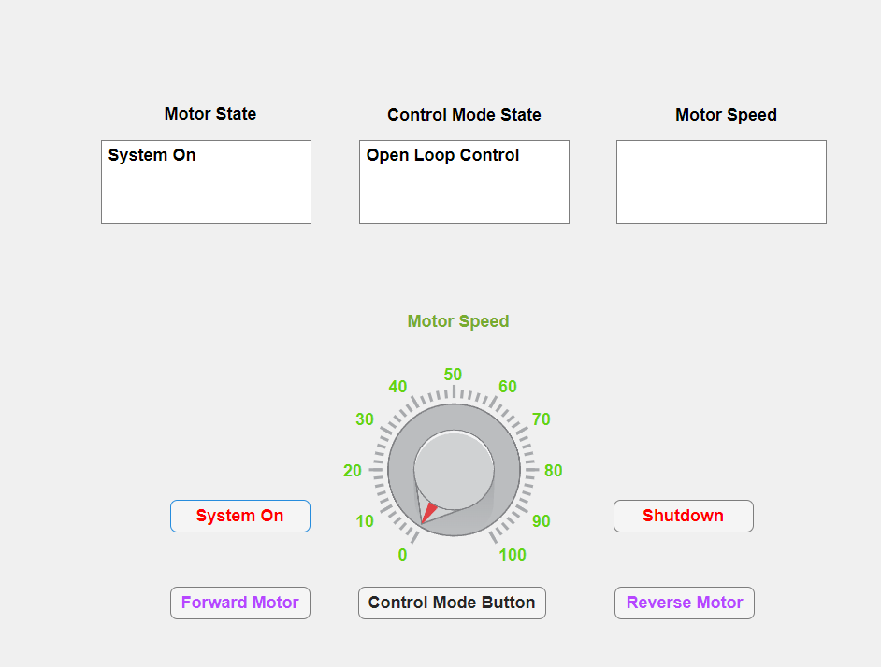
Figure 7: GUI window
This GUI display demonstrated a dial for controlling motor speed as well as few buttons whose function is textually marked (Figure 7). There were three displays namely motor state for showing motor on-off status, control mode state for showing the active speed control type and motor speed that displayed the speed of motor in rpm.

2.3. PWM Generation:
Pin no. 2 and 3 of Arduino were used to generate PWM signals. A potentiometer sensor was deployed to vary the duty cycle. Pin no. 3 governed forward rotation of motor and pin no. 2 governed reverse rotation. In the designed model, these pins are pulled to high voltage (logic level 1) and low voltage (logic level 0). MOSFET driver sensed this voltage change and commanded the MOSFET switches of H-bridge to put 12 V and 0 V across motor terminal for logic level 1 and 0 respectively. This is shown in the Figure 8. By controlling terminal voltage, speed was controlled.
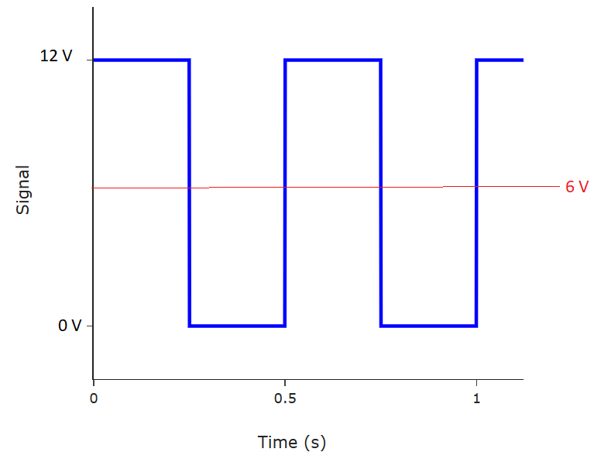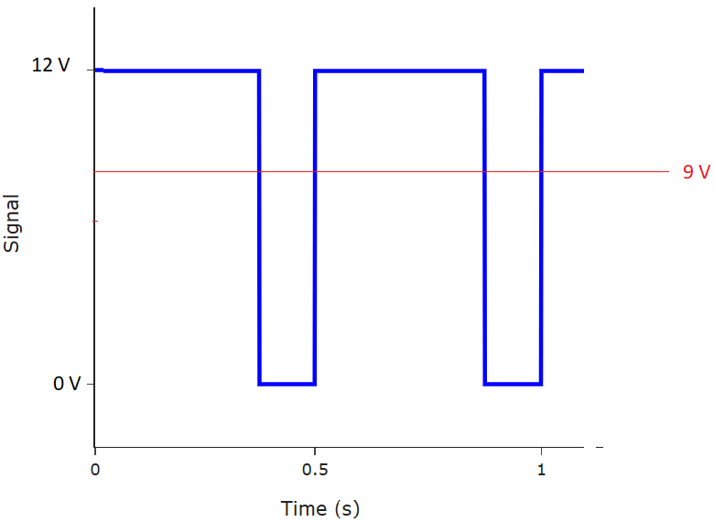
(a) (b)
Figure 8: (a) 50% duty cycle that can produce an average voltage of 6V across motor terminals. (b) 75% duty cycle that can produce an average of 9V across motor terminals.

2.4. PID Parameter Tuning:
The parameters of PID controller were $K_{p} , K_{i} and K_{d}$. They were tuned in such a way that motor speed quickly sticked to reference speed set by user and speed oscillation was minimal.
3. MODEL DESCRIPTION
3.1. Model Construction:
The motor drive designed for EV’s engine is shown in Figure 9. Components used in the project are shown in Table 1.
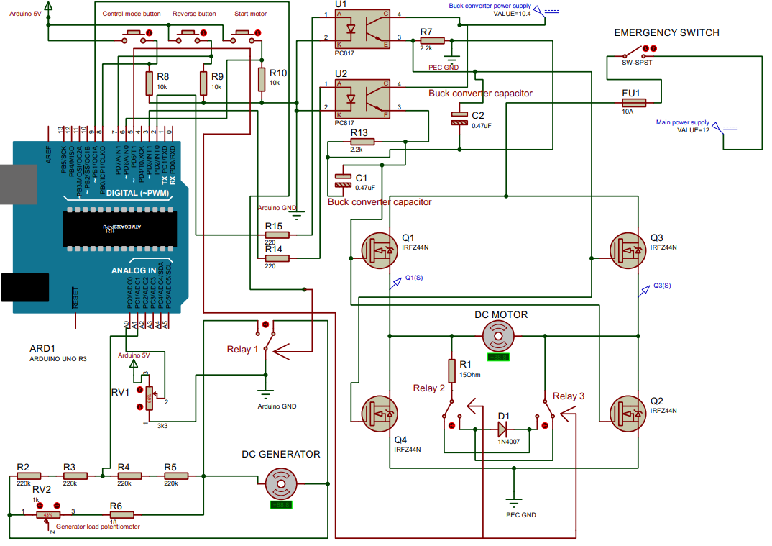
Figure 9: Circuit diagram of the whole prototype

Table 1: List of apparatus used in project
S.L No. | Name of Apparatus | Ratings | Quantity
1 | DC power supply | 11.5 V, 2 A | 1
2 | LM2596 DC-DC buck converter | V_{in} = 11.5V, V_{out} = 10.4 V | 1
3 | Arduino UNO | - | 1
4 | PC817 optocoupler | I_{F} =50mA, I_{C} =50 mA, V_{CEO} =35 V | 2
5 | IRFZ44N MOSFET | I_{D} = 33 A (continuous at 25 ºC) V_{GS(th)} =2-4V at V_{DS} = V_{GS} | 4
6 | 1N4007 diode | V_{PIV} = 1000V, V_{F} = 0.7 V | 1
7 | DC motor (dynamo) | 4-12 V, 4500 rpm | 1
8 | DC generator (dynamo) | 4-12 V, 4500 rpm | 1
9 | Resistor | 220 Ω, 2.2 kΩ, 10 kΩ, 100kΩ, 0.25 W | 5 each
9 | Resistor | 15 Ω, 18Ω, 10W | 1 each
10 | Potentiometer | 1 kΩ, 100 kΩ, 1W | 1 each
11 | Relay switch | V_{trigg} = 5V | 3
12 | Rocker switch | 3A | 1
13 | Push buttons | 0.5mA | 3
14 | Fuse | 10A | 1
15 | Multimeter | 0-50V DC | 1
16 | Breadboard | - | 3
17 | Jumper wires and probes | - | As per need
3.2. Model Operation:
An electric vehicle requires the following operation of motor:
- Accelerating : To speed up the motor when accelerator paddle is pressed
- Braking: To slow the motor when brake paddle is pressed.
- Reverse motion: To drive reverse under reverse gear.
- Speed management: To run motor at constant speed irrespective of load given on vehicle. Weights of passengers vary so this is essential.
Transistor Q1 and Q2 (as per Figure 9) were turned on by pulling up the pin no. 3 of Arduino to high logic. This helps to run motor in forward direction. On the other hand Q3 and Q4 were turned on by pulling up the pin no. 2 of Arduino to high logic and the motor rotates in reverse direction. Logic level of pin no. 3 and 2 are complementary. Following figure elaborates this.
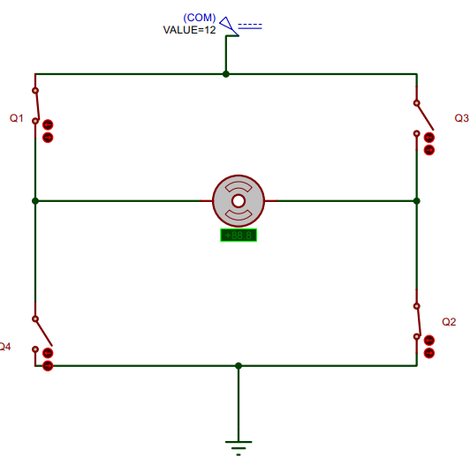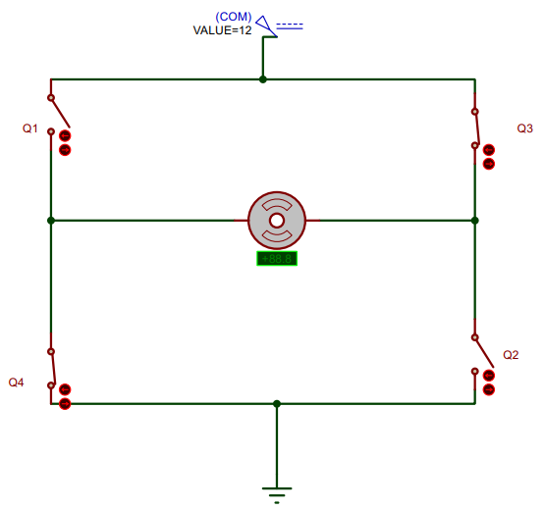
(a) (b)
Figure 10: Equivalent single pole single throw (SPDT) switch circuit of H-bridge converter motor drive for the case of (a) Forward motoring and (b) reverse motoring. Blue arrows show current flow.
Motoring:
Potentiometer sensor connected to analog A0 pin of Arduino is acting as both accelerator paddle and brake paddle. Motor will accelerate if it is turned in a particular way (potentiometer working as accelerator paddle). If turned in other way braking will occur (potentiometer working as brake paddle). If it is held at a particular position, motor will run at almost constant speed. Arduino program is developed in such a way that if potentiometer is rotated to lowest extreme, a duty cycle of 50% will be produced (only for open loop test this is 0 % and not used in normal operation). This is because if the duty cycle was less than 40% (found from open loop test), the motor shuts down completely as its terminal voltage drops down below 4V. In order to keep motor running smoothly, a suitable margin in duty cycle is kept. If potentiometer is taken to its highest extreme, 100% duty cycle is produced to give motor the highest speed. In the GUI application, this action is done by a dial. When the dial is at zero postion, 50% duty cycle will be produced as before and if it is at 100 postion, 100% duty cycle will be produced. Reverse motion of motor is achieved by pressing the reverse gear button. In GUI application, a dedicated button is created for this purpose.
Control modes:
The motor can switch from open loop control to closed loop control and vice versa if the control mode button is pressed. When motor operates in open loop control mode, speed management is not possible. Because, if somehow load on a EV is increased, the motor will slow down. Motor will run faster if load is reduced although driver is holding the potentiometer at fixed position (in real case the driver will press accelerator paddle at constant pressure using leg). That is why when load fluctualtion occurs on the motor of EV, usually happens when driving on uneven roads, it is necessary to drive motor with feedback control.
Open loop control action:
In this mode, motor will run freely as there is no feedback. Arduino will produce duty cycle as per set point given by speed potentiometer. Motor speed can either shoot up or fall down due to load variations but still it will operated with the same duty cycle as set by user. There is no speed correction.
Closed loop control action:
In closed loop mode, output speed of motor is sensed by a generator coupled to it on the same shaft. Generator converts the speed signal into voltage signal for Arduino to read. Arduino has a built in analog to digital converter (ADC) that looks into analog voltage output from generator and discretizes it. A PID controller is set up within the Arduino through programming. This controller takes in reference speed signal (reference duty cycle) from user and output speed signal (transduced output duty cycle) from motor. Then it finds the error signal and modifies it with PID operation. Finally, it produces the required duty cycle for the motor driver to run. If speed to motor somehow falls down from desired speed, the transduced output duty cycle will also fall, resulting in the increment of error signal. If error signal is increased, controller generated duty cycle will also increase. Hence, motor terminal voltage will rise (Figure 8) and motor will speed up to desired speed. If speed of motor increases, transduced output duty cycle will drop down and so will the controller generated duty cycle. As a result motor will get less power and slow down to desired speed eventually.

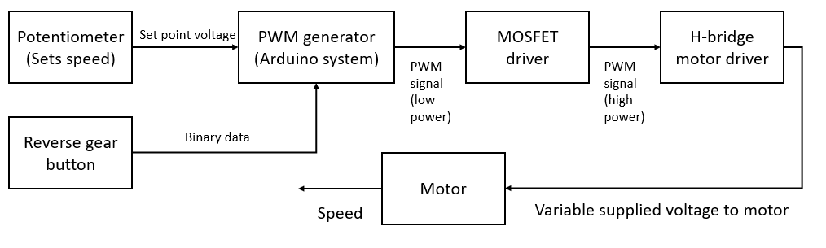
Figure 11: Open loop control of motor speed.
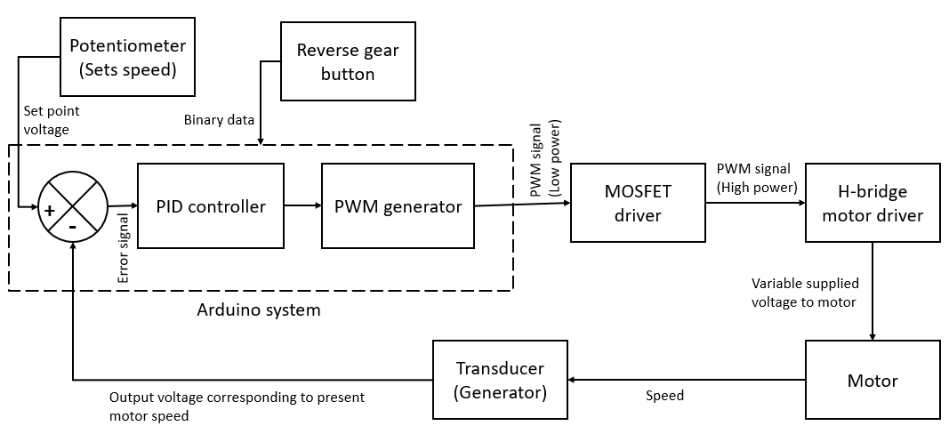
Figure 12: Closed loop control of motor speed

4. RESULTS
Before moving on to main analysis, it is required to express some prefixed data used throughout the experiment.
Table 2: Overview of prefixed data
S.L. no. | Name of data | Value
1 | Time period of PWM signal | 30ms
2 | Frequency of PWM signal | 33.33 Hz
3 | Buck converter output | 10.4 (approx.)
4 | Duty cycle of PWM for lowest motor speed | 50 % (regular operation), 0% (open loop test), 50% (closed loop test)
5 | Duty cycle of PWM for highest motor speed | 100 %

4.1. Open loop motor speed control outcomes.
Table 3: Summary of open loop test
S.L no. | Parameter name | Value
1 | Maximum motor terminal voltage | 7.35V (approx.)
2 | Minimum motor terminal voltage just before motor stops (for 40% duty cycle) | 4V (approx.)
3 | Maximum voltage across generator terminal (this corresponds to maximum motor speed) | 5.5 V (approx.)
4 | Minimum voltage across generator terminal just before motor stops (this corresponds to minimum motor speed at 40% duty cycle) | 2.06 V (approx.)
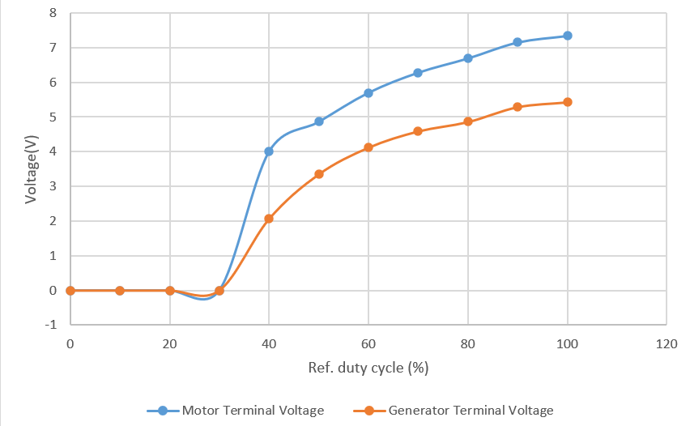

Figure 13: Voltage strength scenario across motor and generator. Generator voltage is notably less than motor voltage. As motor and generator is made with same category dynamo, any substantial deviation indicates energy loss by friction due to coupling faults.

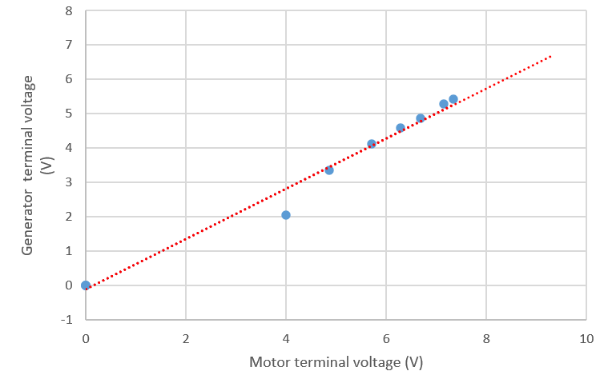
Figure 14: Linear trend relation between motor and generator terminal voltage. To measure motor speed correctly, the generator voltage should have a linear link with motor speed which in turns is expressed by motor terminal voltage.
At the outset of this experiment, observations suggest that there was much vibration when motor rotated the generator. For this reason, much of the kinetic energy of motor was lost by heat and sound. A small bend on the shaft of motor was found when it was connected to generator. It was made straight by tightening the coupling pegs. After the correction, the loss was minimized but still notable as shown in Figure 13.
Generator is used as a sensor or transducer. So, the input and output signal of generator should be linearly related. An almost linear behavior was found and depicted in Figure 14. So, this generator could be used effectively as a sensor.
Data corresponding to Figure 13 and 14 was stored in the github repository. Link is given in the appendix.

4.2. Closed loop motor speed control outcomes:

Table 4: Summary of closed loop test
S.L no. | Parameter name | Value
1 | Maximum voltage across generator terminal (this corresponds to maximum motor speed) | 4.8 V (approx.)
2 | Minimum voltage across generator terminal (this corresponds to minimum motor speed at 50 % duty cycle) | 3.3 V (approx.)

In this test, the main objective was to find is to find the correlation between motor’s current speed and setpoint speed. Motor should run at constant speed set by vehicle driver regardless of any load on it up to a certain limit. In the figure 15, it was seen that PID controller has generated a duty cycle that almost match with output duty cycle. Here, output duty cycle is obtained by measuring motor speed by generator terminal voltage. Output duty cycle represents nothing but the present speed of motor mapped to an equivalent numeric figure. When this duty cycle is close to 100 %, it means that the present speed is maximum. When this is close to 50 %, speed is minimum.
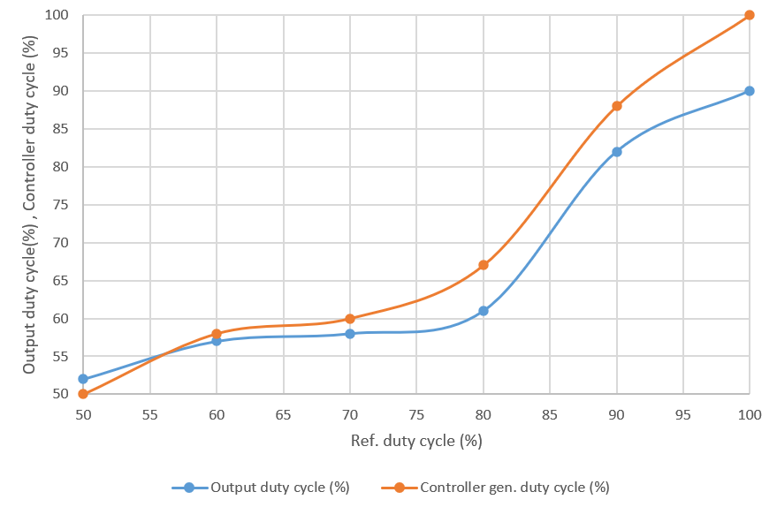
Figure 15: Variation of output and controller gen. duty cycle with ref. duty cycle

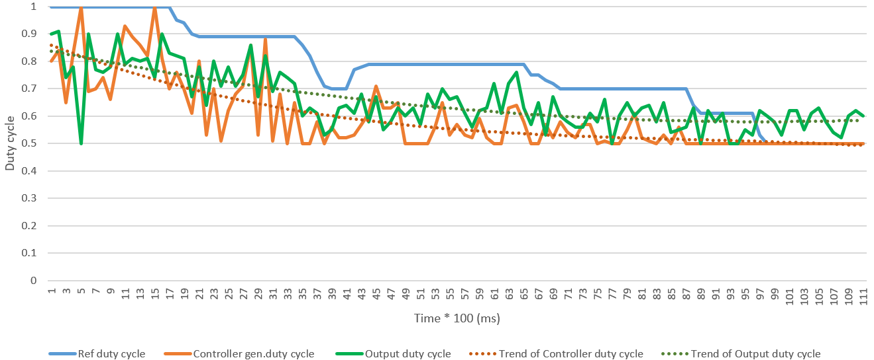
Figure 16: Real time data of PID response
There was a high ripple in motor speed at the very outset of closed loop test. By hearing the changes of motor vibration, the ripples could be perceived easily, After tuning PID controller’s parameters, such oscillations were removed a lot and then no audible fluctuation of motor vibration was apparent. Still, small ripples were visible when real time data of generator terminal voltage was collected by Arduino’s serial communication medium (green graph of Figure 16). However, if a polynomial regressor (indicated by orange dots in Figure 16) was plotted, it was found that when ref. duty cycle was reducing, output duty cycle was also reducing and it indicates a stable closed loop control. PID controller was also responding fast towards the oscillations of motor speed. This was evident from Figure 15 as there was a small gap between output duty cycle and controller generated duty cycle. Polynomial regressor of output and controller generated duty cycle also had low deviation ( Figure 16).

4.3. Calibrated figures in a nutshell:

Table 5: List of calibrated Data
S.L no. | Name of Data | Calibrated value
1 | Microcontroller ADC output for maximum generator output voltage | 640
2 | Proportional gain of PID controller, K_{p} | 0.1
3 | Integral gain of PID controller, K_{i} | 0.4
4 | Derivative gain of PID controller, K_{d} | 0.01

5. CONCLUSIONS

This project has prototyped a H-bridge driver capable of driving DC motors installed in EVs. The H-bridge driver can switch between open and closed loop control modes. It also has a capability to supply excess inductive power to an alternative low power source provided that the main supply is unwilling to accept power. Although the functioning of the devised model is satisfactory, much improvements can be made in the design. If a non-invasive electronic speed sensor is used instead of generator, then energy loss due to attachment faults can be minimized. However, this will require another system for giving loads on motor as generator can impose load on motor and can be controlled by armature current of generator beside working as a sensor.

6. REFERENCES
- D. M. Bellur and M. K. Kazimierczuk, "DC-DC converters for electric vehicle applications," 2007 Electrical Insulation Conference and Electrical Manufacturing Expo, Nashville, TN, USA, 2007, pp. 286-293, doi: 10.1109/EEIC.2007.4562633.

- “Understanding H-bridge Drivers: The Key to Motor Control, ” IBE Electronics, November 8, 2025, Avalable [Online.] https://www.pcbaaa.com/h-bridge-drivers/

Garaipoom, “Basic H-bridge motor driver circuit using bipolar transistor,” ElecCircuit, November 8, 2025, Available [Online.] https://www.eleccircuit.com/basic-h-bridge-motor-driver-by-bipolar-transistor/

“Freewheeling Diode”, GeeksforGeeks, “November 8, 2025, Available [Online.] https://www.geeksforgeeks.org/electrical-engineering/freewheeling-diode/

B.L. Theraja et.al, “Speed Control of D.C Motors,” in A TEXTBOOK OF ELECTRICAL TECHNOLOGY IN S.I. UNITS: volume II, 1st ed. New Delhi, India: S. CHAND AND CO. LTD, 2009, ch.30, sec. 30.1, p.p. 1032

R. Mundrathi, “What Is PID Controller, Working, Advantages, Disadvantages, Applications,” CSEE, November 8,2025, Available [Online.] https://www.cselectricalandelectronics.com/what-is-pid-controller-working-advantages-disadvantages-applications/

APPENDIX
All the necessary files associated with the project can be found in a github repository with the link below:
git@github.com:projectohid/4110_project.git

